X pense | Features about us pricing feadback | Request a demo
Track your Expenses to save money |  |   Illustration.svg
Helps your organize your income and expenses
Try a free demo (bouton) | -web, iOS and Android
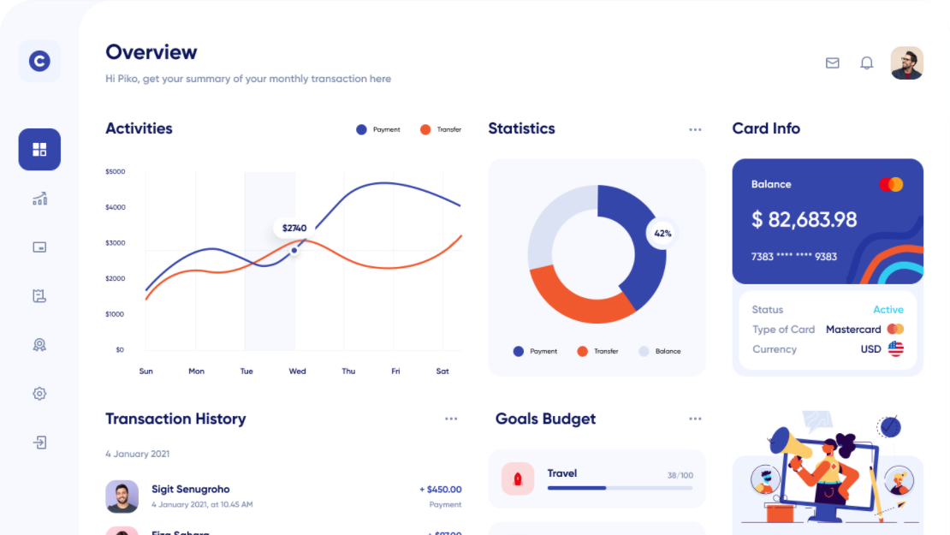
Image.svg
Logo facebook google Coca Cola Linked in Samsung

Always online
Real time support with cloud |   Illustrator-1.svg
Tellus lacus morbi satittis lacus in.Lorem ipsum dolor sit amet, consectetur adipiscing elit. Integer nec odio. Praesent libero.

Learn more ->

Choose your flexible plan
Starter plan | Silver plan | Diamond plan
- Store unlimited data  - export to pdf, xls, csv  - cloud server support | - Store unlimited data  - export to pdf, xls, csv  - cloud server support | - Store unlimited data  - export to pdf, xls, csv  - cloud server support
$ 9,99/year  up to 3 user + 1,99 per user | $ 19,99/year  up to 3 user + 1,99 per user | $ 29,99/year  up to 3 user + 1,99 per user
Get This | Get This | Get This

20 M+ downloaded from 32 different countries

Try demo for 7 days with full features.


Illustrator.svg

Try Free demo
X pense | LINKS | LEGAL | NEWSLETTER
 | - Home  - About us  - Careers  - Pricing  - Features  - Blog | - Term of use  - Term of conditions  - Privacy policy  - Cookie policy | Over 25 000 people have subscribed
 |  |  | Enter your email subscribe
 |  |  | We don’t sell your email and spam
Privacy & Terms | Contact us | Copyright © 2022 xpense | Logo facebook linkedin twitter

Flex
Grid

ce sont des div

Header

Header

Header

NAV

X eNSE

